FBI Omaha CAAA – Annual Report 2017

2018 Board of Directors

Tony Moody, President Sharon Rasmussen, Vice President
Kelly Walters, Treasurer Randy Cairns, Vice President
Jim Hanson, Secretary Pam Wiese, P.R.
Todd Studnicka Michelle Bandur
Mark McGregor Steve Patterson
Kim Wolfe Kevin Nokels
Troy Bruckner Chris Chapman
Joe Spedea
Herb Hames, Immediate Past President

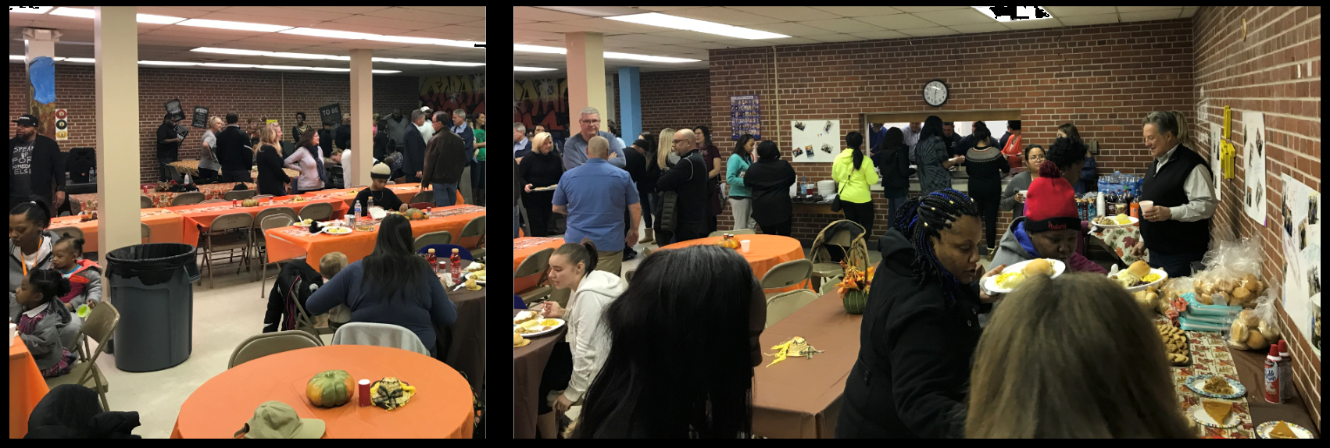

Chronological Summary Review of Events – January 1, 2017 to December 31, 2017

March 20th Omaha & March 21st Des Moines:
Steve Conlon from the FBI Academy Behavioral Science Unit led us in a 2 ½ hour presentation. This event was very educational, social and informative.

April 25th Tour of the New Omaha Police Department SW Precinct and Private Briefing. A social and networking event was held immediately following the tour.

June participated in the 4th Annual Ames Avenue Block Party with nearly 1,000 people. The festivities included community service information booths, music, dance raffles, fun and food.

August 24th was the 28th Annual FBI Omaha Division Golf Outing at Tiburon. There were over 40 teams of 4 that supported this great cause with donations going to the Memorial College Education Fund and the FBI OCAAA. The day conclude with dinner and special recognition for the over 200 golfers/volunteers.

October our chapter fed 1,000 of the First Responders that were on the Las Vegas shooting scene. It was very heartwarming to see how many people came together to try and make this difficult situation better.

October our chapter hosted “Confessions of a Victimized Company” – U.S. vs Xiwen Huang: An Insider Threat Case Study. There were 80-100 business leaders, CEOs and Presidents of companies that received a first hand account of what “can” happen.

In November we teamed with Boys Town and the FBI Agents to serve a Thanksgiving luncheon to the students, faculty and their families at the Omaha Street School. Over 100 meals were served.

Respectfully,
Tony Moody
President of the Board
Tony.Moody@JQH.com

GUIDELINES FOR REPORT – Please follow this template without any variations. Keep your report to no more than two pages and one photo.

